**TechConnect Pro Network Architecture Design**

**Name: Gopikrishna Mogilicharla**

**Github URL: https://github.com/gmogilicharla/Project**

**SQL environment (Windows)**

**TechConnect Pro network**

2 insert statement:

|  |
| --- |
| INSERT INTO product VALUES (4,'Keyboard','Accessories',40,'Used to give input to system',15);  INSERT INTO device VALUES (5,'Server','External Network Layer',12); |

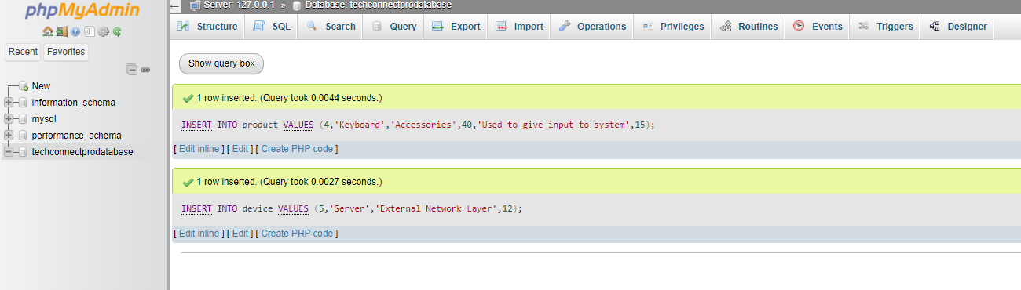

2 update statements:

|  |
| --- |
| Update product set Price = 30 where ProductID = 4;  Update device set Type = 'Internal Network Layer' where DeviceID = 5; |

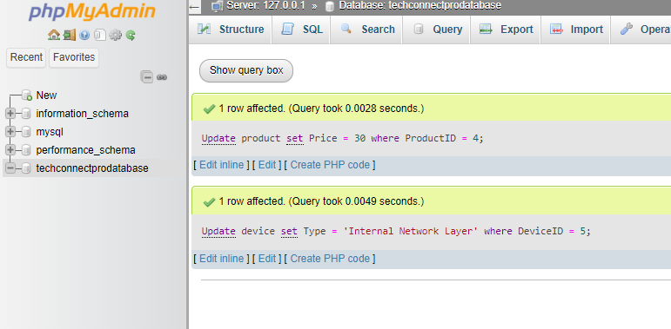

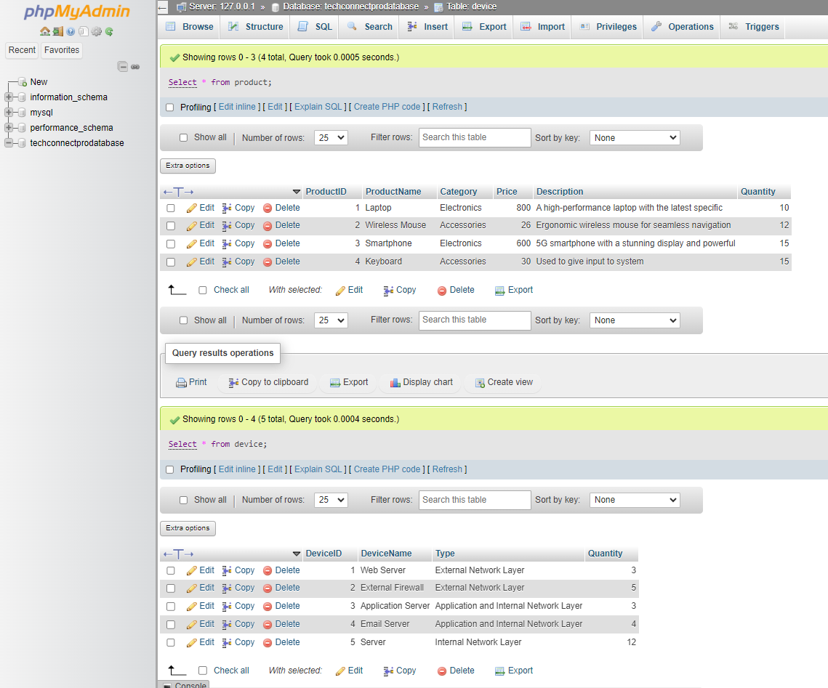

Delete 1 record:

|  |
| --- |
| Delete from device where DeviceID = 5;  Select * from device; |

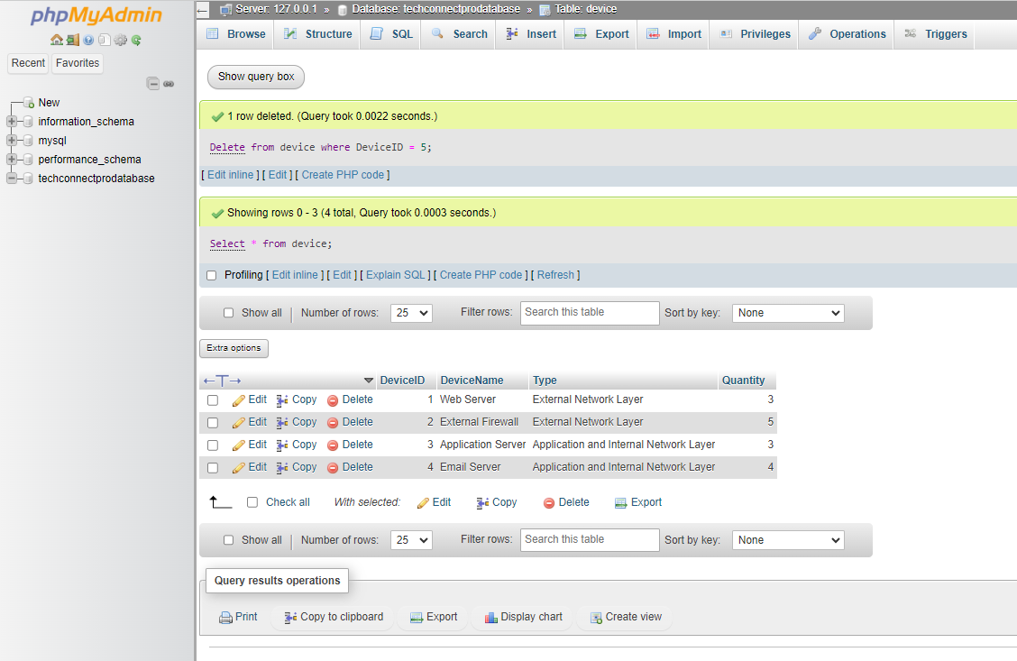

Simple Select statement selecting Subset:

|  |
| --- |
| Select * from supplier where SupplierID = 3; |

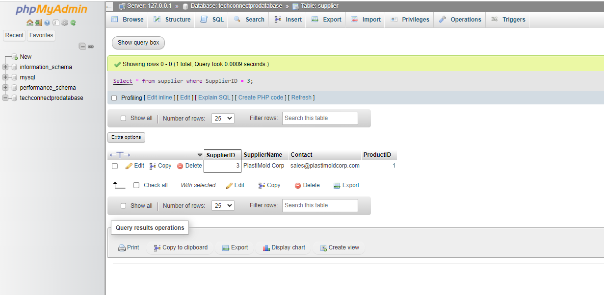

2 select statements with joins:

|  |
| --- |
| SELECT A.*, B.* FROM device A right join deploy B ON A.DeviceID=B.DeployID;  SELECT A.*, B.* FROM product A right join deploy B ON A.ProductID=B.ProductID; |

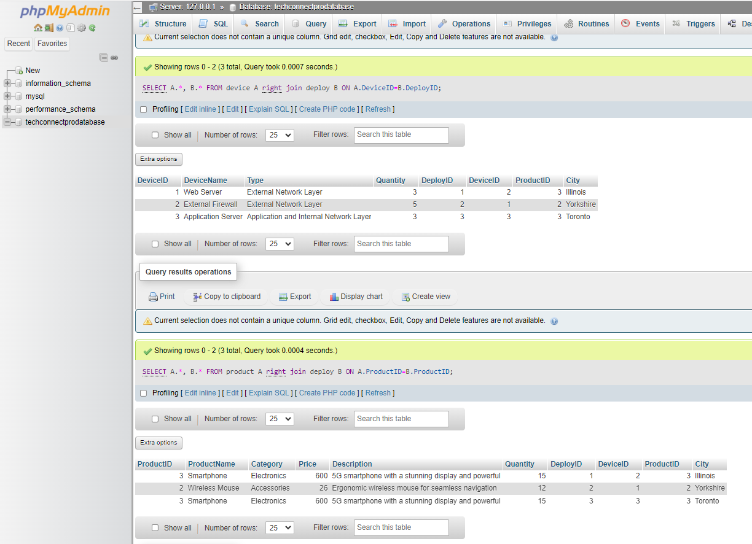

2 Summary functions SQL Statements:

|  |
| --- |
| SELECT ProductID,sum(Quantity) FROM product group by ProductID;  SELECT A.ProductID, A.ProductName, case when Quantity<20 then 'Need More Stock' else Null end as QuantityWarning FROM product A; |

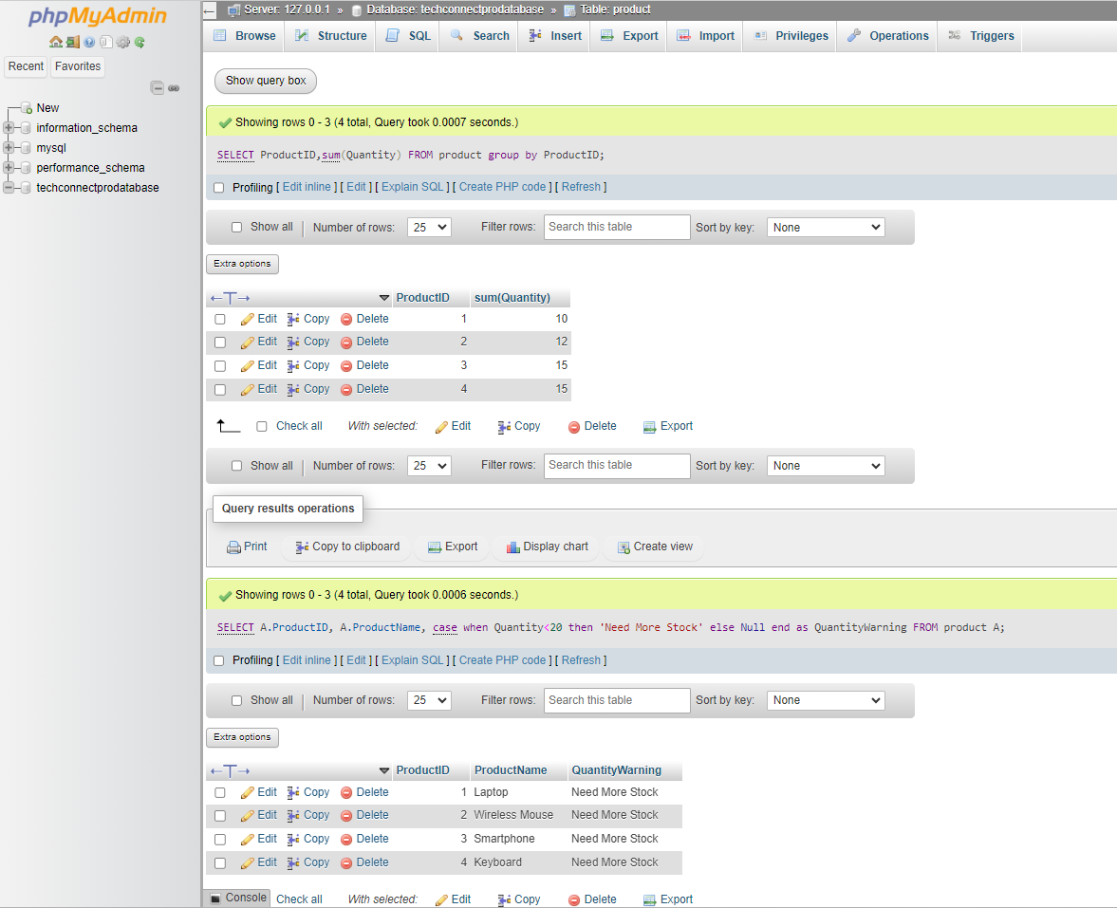

Multitable Query:

|  |
| --- |
| SELECT A.*, B.City, B.ProductID, C.SupplierName FROM product A inner join deploy B  ON A.ProductID=B.ProductID  inner join supplier C  ON B.ProductID=C.ProductID |

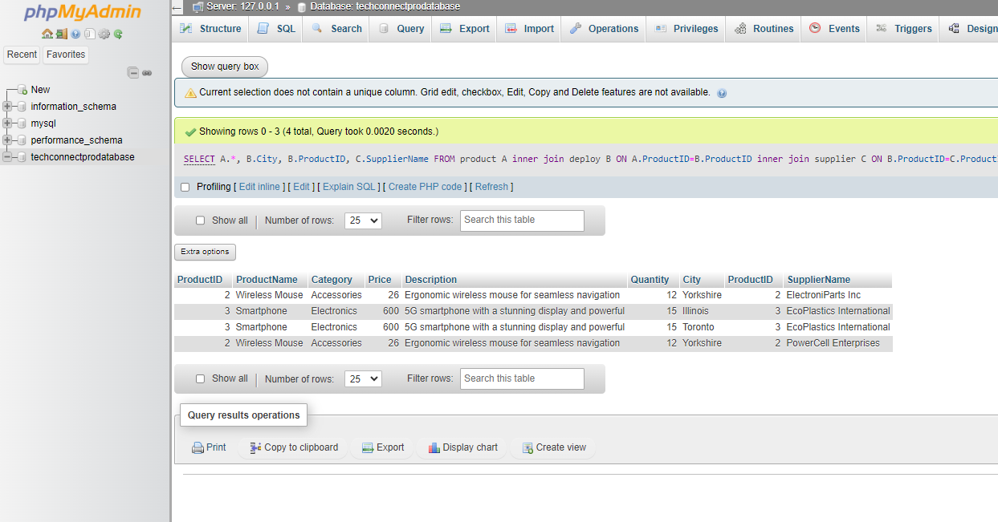

Add ENUM:

An enumeration (ENUM) is a data type in which a string object is assigned a value from a predetermined list of expressly defined options during the establishment of a table's column specification. The system restricts the user from inputting any item that is not included in the offered alternatives.

|  |
| --- |
| ALTER TABLE device add column deviceutility ENUM ('Useable','Non-Useable') not null ;  Select * from device; |

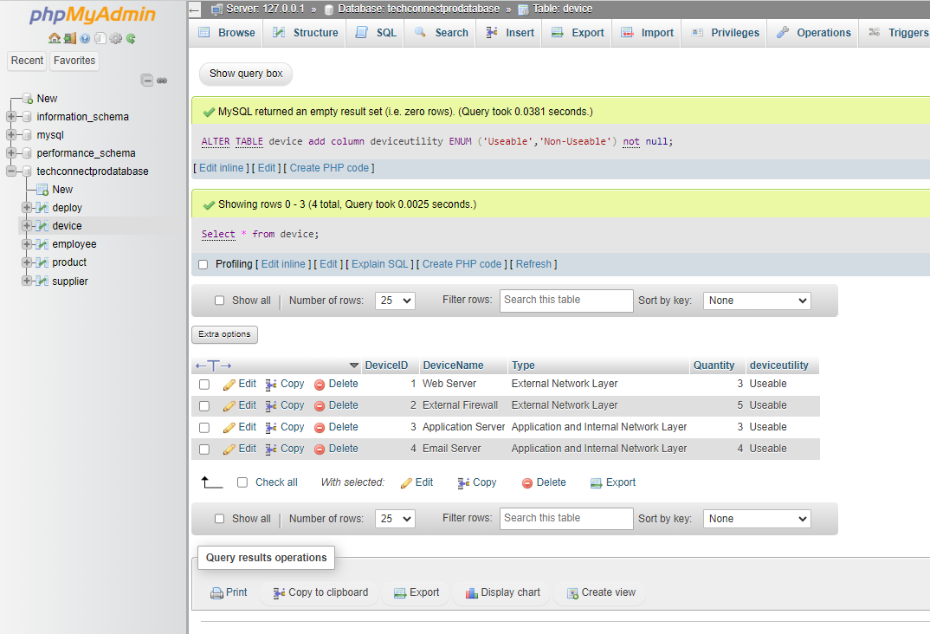

Adding Constraint Not NULL:

|  |
| --- |
| alter table device modify DeviceName varchar(50) not null;  Select * from device; |

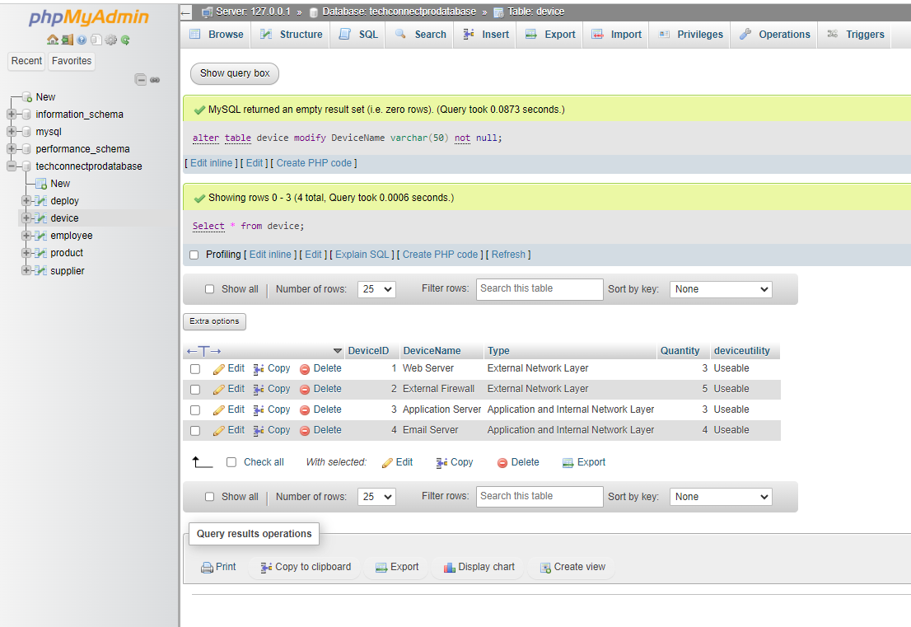

Insert new record to the above table:

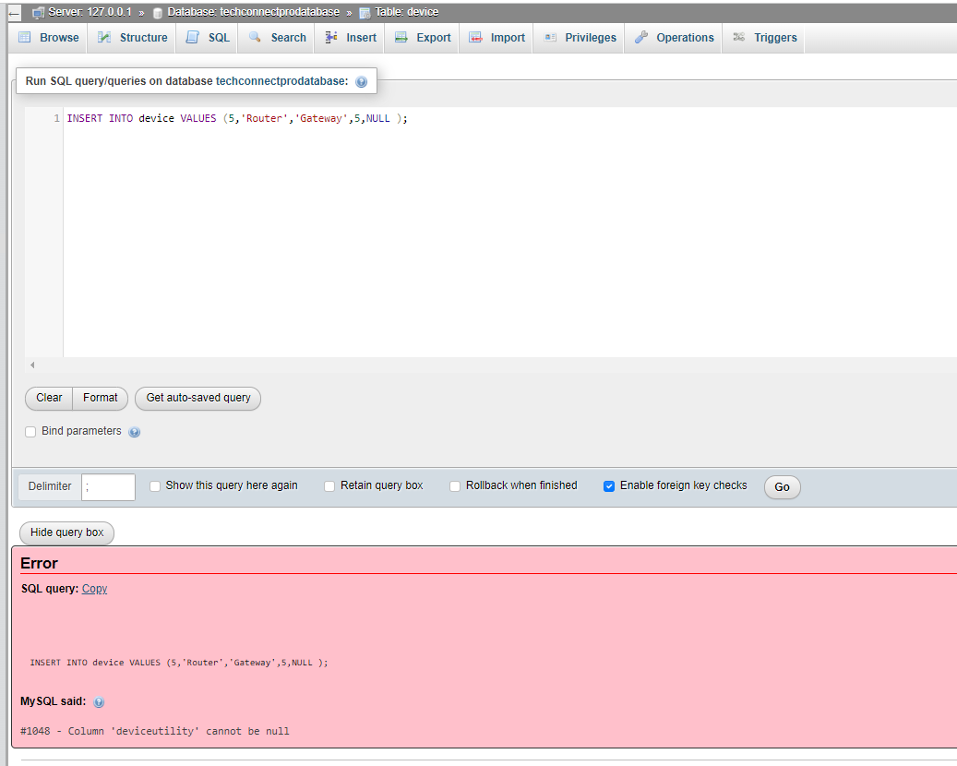

|  |
| --- |
| INSERT INTO device VALUES (5,'Router','Gateway',5,'Useable' ); |

Update and Delete is the option that we can use to make change in above manipulated table. Lets apply the update statement.

|  |
| --- |
| Update device set deviceutility = 'Not-Usable' where DeviceID = 5;  Select * from device; |

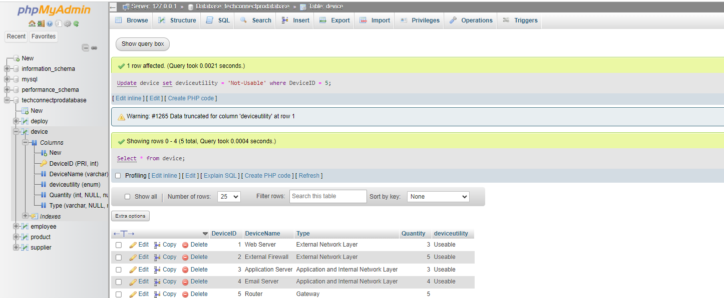

Delete New Record:

|  |
| --- |
| delete from device where DeviceID = 5; |

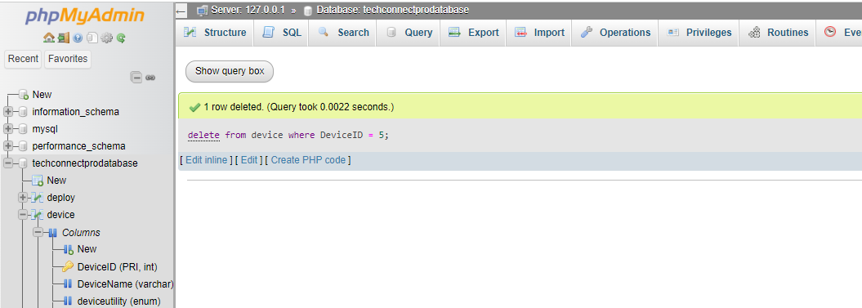

Auto Increment by adding a new Column in a table

|  |
| --- |
| Alter table employee add column BatchNum int AUTO_INCREMENT not null unique key; |



